**Assignment No.2**

**Ethernet cable, Color Code, Crimping**

* **T568A and T568B Wiring Standard**

A RJ45 connector is a modular 8 position, 8 pin connector used for terminating Cat5e patch cable or Cat6 cable. A pinout is a specific arrangement of wires that dictate how the connector is terminated. There are two standards recognized by ANSI, TIA and EIA for wiring Ethernet cables. The first is the T568A wiring standard and the second is T568B. T568B has surpassed 568A and is seen as the default wiring scheme for twisted pair structured cabling

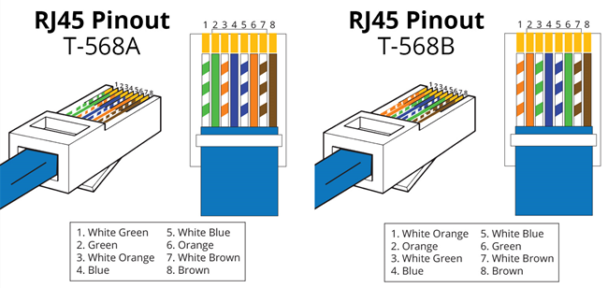

**What Is Straight Through Cable?**

A straight through cable is a type of twisted pair cable that is used in local area networks to connect a computer to a network hub such as a router. This type of cable is also sometimes called a patch. On a straight through cable, the wired pins match. Straight through cable use one wiring standard: both ends use T568A wiring standard or both ends use T568B wiring standard. The following figure shows a straight through cable of which both ends are wired as the T568B standard.

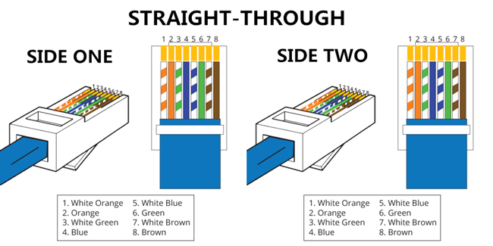

**What Is Crossover Cable?**  
A crossover Ethernet cable is a type of Ethernet cable used to connect computing devices together directly. Unlike straight through cable, the RJ45 crossover cable uses two different wiring standards: one end uses the T568A wiring standard and the other end uses the T568B wiring standard. The internal wiring of Ethernet crossover cables reverses the transmit and receive signals. It is most often used to connect two devices of the same type: e.g. two computers (via network interface controller) or two switches to each other.

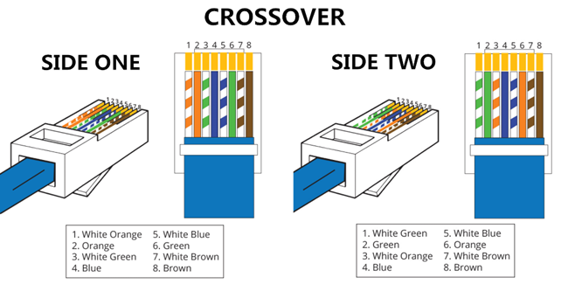

**Ethernet Cable Instructions:**

* Pull the cable off the reel to the desired length and cut. If you are pulling cables through holes, its easier to attach the RJ-45 plugs after the cable is pulled.
* Start on one end and strip the cable jacket off (about 1″) using a stripper or a knife. Be extra careful not to nick the wires, otherwise you will need to start over.
* Spread, untwist the pairs, and arrange the wires in the order of the desired cable end. Flatten the end between your thumb and forefinger. Trim the ends of the wires so they are even with one another, leaving only 1/2″ in wire length. If it is longer than 1/2″ it will be out-of-spec and susceptible to crosstalk. Flatten and insure there are no spaces between wires.
* Hold the RJ-45 plug with the clip facing down or away from you. Push the wires firmly into the plug. Inspect each wire is flat even at the front of the plug. Check the order of the wires. Double check again. Check that the jacket is fitted right against the stop of the plug. Carefully hold the wire and firmly crimp the RJ-45 with the crimper.
* Check the color orientation, check that the crimped connection is not about to come apart, and check to see if the wires are flat against the front of the plug. If even one of these are incorrect, you will have to start over. Test the Ethernet cable.